Pike County Career Technology Center
Firefighter Training Program
Fire Charter # 215
175 Beaver Creek Rd.
Piketon OH 45661
Phone: 740-289-2282 or 289-4172
Fax: 289-4932
www.pikectc.org

Pike County Career Technology Center
Fire Charter # 215

Firefighter Training Program
Student Handbook

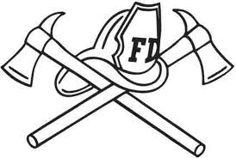

Non-discrimination Policy Statement
The school board has dedicated itself to providing equal admission opportunities and equal employment opportunities to all people regardless of race, color, national origin, sex, age, religion, ancestry or disability.

Updated August 19, 2024

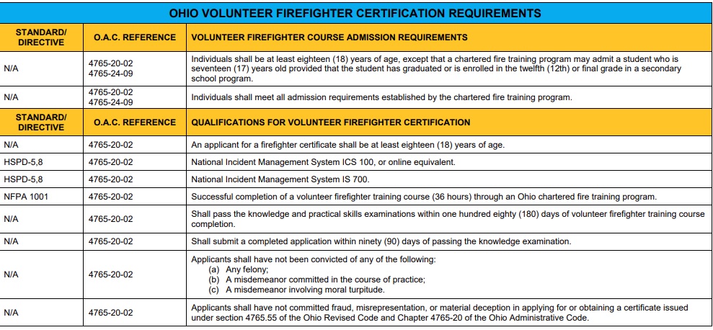

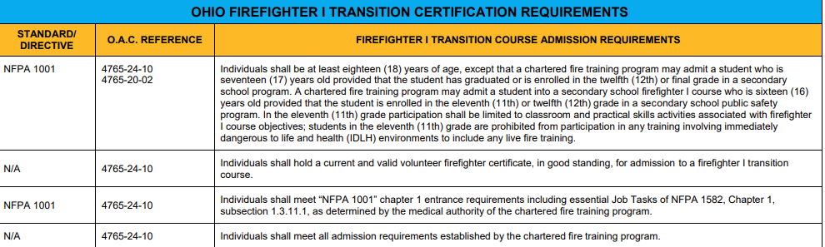

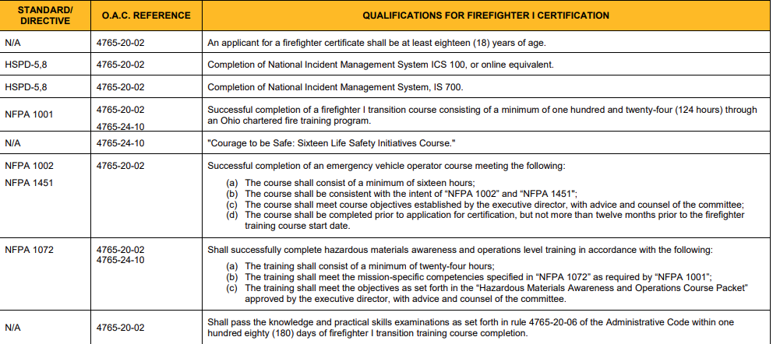

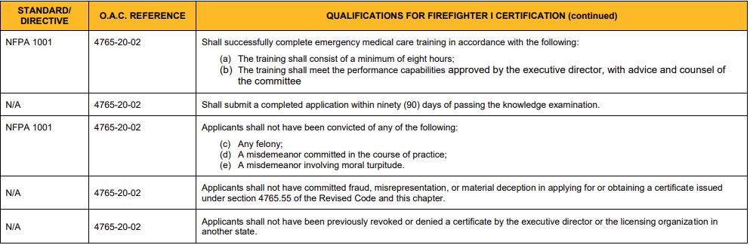

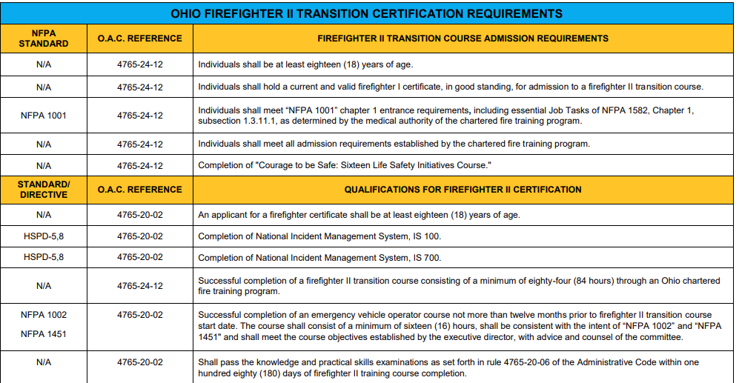

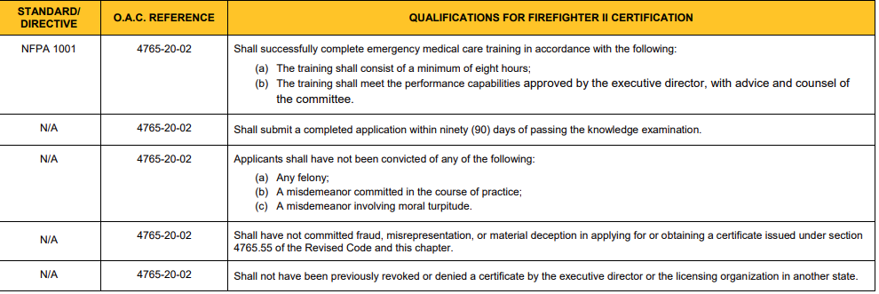

Pike CTC Policy: Admission

A student entering into a fire program must meet the following criteria before being permitted in the course. All admission applications must be reviewed prior to the first day of training to ensure eligibility:
- Are at least 18 years of age and are not attending high school, except that a fire service training program may admit a student who is 17 years old provided that the student is enrolled in the twelfth or final grade in a secondary school program or has already graduated;
- Have not been convicted of, pled guilty to, or had a judicial finding of guilt for any of the following:
  - Fraud or material deception in applying for, or obtaining certificate;
  - A felony;
- If individual has had a felony conviction, they are not permitted to be admitted
into a fire training program.
  - A misdemeanor of moral turpitude;
- This is to be determined by the charter institution. The determination of the
charter institution is final.
Or a misdemeanor committed in the course of practice.
  - A violation of any federal, state, county or municipal narcotics law.
  - Any act committed in another state that, if committed in Ohio, would constitute a
violation.
  - Have not been adjudicated mentally incompetent by a court of law;
  - At the time of admission, are not under indictment for a felony or a misdemeanor
involving moral turpitude;
  - Do not currently engage in the illegal use of controlled substances, chemical sub-
stance, or other habit-forming drugs, or engage in the use of alcohol to an extent
that it impairs the ability to perform the duties of a firefighter or fire safety inspector.
- In addition to the requirement listed above, the admission requirements for a fire safety
inspector training program shall include the following:
  - The applicant is employed by one of the following:
- The office of the state fire marshal;
- A fire fighting agency as defined in division (A) (1) of section 9.60 of the Revised Code;
- A private fire company as defined in division (A) (2) of section 9.60 of the Revised Code that is providing fire protection in accordance with division (B), (C), or (D) of section 9.60 of the Revised Code;
  - The applicant submits a letter of recommendation from an employer;
  - The applicant holds a current fire fighter certificate issued by the Division of EMS.

- The student must have a high-school diploma or GED unless the student is still enrolled in the 12th grade.
- The student must be sponsored by a fire department.
- Student must show documented proof of successful completion of all federal and state required coursework and requirements.
- Student must have a signed Registration/Release form on file.
- Must present a valid physical completed within the preceding 12 months -Volunteer Level & FFI.
- Must have a valid driver’s license -FFI Level.
- Must present a copy of their valid Vol FF card – for FFI, or their valid FFI card – for FFII.

Policy: Completion
Complete all required coursework with an overall grade of 80% or better. [High School is 70% or better.]
Successfully complete all program Objective Skills.
Meet attendance requirements and make-up any missed assignments or hours.
Pass all required Practical Skill Examinations.
Successful completion of any coursework and requirements imposed by law.

Policy: Attendance
Volunteer FF program
VOL FF STUDENTS CAN NOT MISS ANY CLASS.
The Volunteer Firefighter program requires 100% attendance.
Students will be dismissed if they miss any class.

FFI, FFI Transition, FFII and FFII Transition
FFI, FFI Transition, FFII and FFII Transition students are permitted to miss TWELVE (12) HOURS TOTAL.
Students will be dismissed if they miss more than 12 hours.
ALL HOURS & CONTENT MISSED DUE TO ABSENCE(S) MUST BE MADE UP.
STUDENTS CAN NOT MISS THE LIVE FIRE CLASS.

FFI High School Students - enrolled at the Pike CTC High School
FFI High School students, enrolled at the Pike CTC High School, must make up all missed hours and classes.
All missed content, objectives, and skills must be made up – hour-for hour – as time in the schedule permits.
High school FFI students who do not make up all missed hours will not be eligible for a Certificate of Completion and therefore will not be eligible to sit for the FFI state certification exam.

Policy: Make-up Work
All missed work & assignments must be successfully made-up. Every hour missed must be made-up hour-for-hour. The student must make-up the missed time by attending the scheduled Review/Make-up session or by other arrangements approved by the school.
Failure to adhere to the attendance policy will result in dismissal from the program. Failure to make-up work hour-for-hour will result in not completing the program and therefore a non-issue of Certificate of Completion.

Tardiness
Students are expected to report to class prior to the scheduled start time and remain in class until the instructor’s dismissal. Students who are 10 or more minutes tardy will be dismissed from the program upon the second occurrence. Students who leave prior to dismissal will be dismissed upon second occurrence. All work missed must be made-up according to the policy.

Policy: Grounds for Dismissal
Respect for people and property is expected at all times from all students. Any misconduct or disruptive behavior may result in the student being dismissed from the program. The Instructor(s) and the Adult Education Director may terminate a student’s enrollment at any time and at his/her discretion for the disruption of the learning environment in the classroom/lab, for improper conduct toward another person, for destruction of school or fire department property, fighting, insubordination, cheating, plagiarism, lack of cooperation or interest, sexual harassment, safety violations, extreme horseplay, failure to meet the attendance requirements, or failure to adhere to school policy.

Policy: Student Attire
Students are expected to dress appropriately, defined as: the appropriate dress that would be expected at a work-site related to the student’s program of training. Instructors and administrators have the authority to ask inappropriately dressed students to leave the school and return with the proper attire.

Policy: Student Personal Protective Equipment (PPE)
Students must have the required PPE that meets or exceeds minimum industry standards. Students without the proper and required PPE will not be permitted to participate in training activities for the day. All PPE must be properly fitted. Students with improperly fitted PPE will not be permitted to participate in training activities for the day.

Policy: Student Facial Hair
Students are not permitted to have facial beards due to safety regulations and standards.
In accordance with Ohio Admin. Code 4123:1-21-02(P)(10)
The employer shall not permit any known interference with the facepiece-to-face
seal or with the operation of the exhalation valve on the full facepiece of
an "SCBA" on employees who are exposed to hazardous atmospheres from fires
and other emergencies or where the potential for such exposure exists.

Policy: Class Information / Schedule
Information regarding course schedule and objectives will be distributed to each student during the first night of class. Students can call the Pike County CTC, Adult Education Office and obtain information on the appropriate class in question.

Policy: Refund Policy
A 100% refund will be administered if a student withdraws during the first week of class. Once a student has attended one class meeting, no refunds will be administered. Sponsored students receiving Veteran Benefits will receive a pro-rata refund based upon the time of withdrawal.

Policy: Pre-Requirements For Advanced Courses
For programs beyond basic fire training levels, satisfactory completion and state certification of all lower level prerequisite programs is a condition for admission. Documentation must be provided to verify certification.

Policy: Grading and Evaluation
Each student will be assessed by the program instructor. Part of the evaluation may consist of, but not limited to, the following:
Classroom work and test grades Quality of work
Attitude Ability to work with others
Attendance Safety practices
Tardiness Work ethic and initiative
Care of school property, tools, equipment, etc. Homework assignments
Lab work and assignments Special projects
Successful completion of objectives within certification level

Policy: Clean Up
Students are expected to help clean up the work space including washing all equipment and vehicles as directed. Class dismissal times may be extended past schedule to make certain these duties are properly completed. Refusal to participate in clean up duties will be regarded as blatant insubordination and may be grounds for dismissal.

Policy: Grading Scale
The following grading scale will be used to reflect a composite score of both laboratory, skill and classroom related performance.
A 96 - 100
B 87 - 93
C 80 – 86
The course is evaluated as PASS/FAIL .
80% is the minimum passing grade for ADULT EDUCATION PORGRAM.
70% is the minimum passing grade for HIGH SCHOOL PROGRAM.

Program Cost

Volunteer Firefighter (36-Hour)
Tuition $370
Books $125
Materials $0
Total $495

Firefighter 1 Transition (36-Hour Vol. to FF I) Firefighter I
Tuition $990 Tuition $1190
Books $125 Books $125
Materials $0 Materials $0
Total $1115 Total $1315

Firefighter I to II Transition (FF I to FF II)
Tuition $865
Books $125
Materials $0
Total $990

Grievance Policy
If the student is dismissed by the instructors and wishes to appeal, they must put their grievance in writing and submit their complaint to the adult education director no later than five (5) days after their dismissal. The director will seek information from all involved participants and make a timely decision regarding the dismissal. If the director does not uphold the decision of the instructor the student will be permitted to make up all work missed and receive appropriate credit. If the director does not uphold the instructor’s decision, students have one (1) year to attempt missed objectives due to any absences relating to dismissal. The school will not schedule independent objective skills tests. (See Completion Requirements)
If the student wishes to appeal the decision of the adult education director for dismissal the student must file a written notice of his/her intention to do so with the superintendent no later than five (5) days after receipt of written decision of director. If an appeal is filed within that time, the student shall meet with the superintendent and be give the opportunity to present any evidence to overturn the decision. The superintendent shall consider the evidence and provide the student with his/her decision in writing. The decision of the superintendent is final. If the superintendent does not uphold the dismissal the student is permitted to make up all work missed and receive the appropriate credit. If the superintendent does not uphold the director’s decision, students have one (1) year to attempt missed objectives due to any absences relating to dismissal. The school will not schedule independent objective skills tests.

Student Healthcare Services
Emergency services will be contacted for any student who is injured or becomes ill during class or lab exercises, unless otherwise requested by the student. The school will only be responsible for making these services available to the student. Any financial responsibility rests with the student. Any student injured or becoming ill during class or laboratory session is required to report the incident to the instructor immediately. Instructors will be required to complete an Accident Report Form.

Policy: Chemical Abuse/Dependency
Students must not be under the influence of drugs and/or alcohol when they report to class, lab or clinical. The use, sale, transfer, or possession of a controlled substance or alcohol by students creates the potential for harm to oneself and to others.

It is an ethical and professional responsibility of all students to conduct themselves in a manner consistent with the provision of an environment free from threat to person, property, efficiency or reputation as a consequence of illegal use, sale, transfer, or possession of alcohol or dangerous drugs as defined by Section 4729.02 of the Ohio Revised Code (Definitions, Pharmacy Act). The school supports and will cooperate with authorities at the local, state, and federal levels regarding the regulation of alcohol and drug abuse. The Pike County Career technology Center will notify legal authorities in accordance with Section 2921.22 of the Ohio Revised Code. The school will not protect a student in violation of the law from prosecution under federal, state or local law. Appropriate referrals will be made (if needed) to the Scioto County Paint Valley Mental Health Center.

Policy: Reasonable Suspicion On-Site Drug Testing
An on-site drug screening may be conducted at the discretion of the Adult Education Director in cases of reasonable suspicion. If the drug screen is positive or if the student refuses to undergo the screening, the student will be dismissed.
The drug screen will be sent for lab verification. The student will be informed in writing of this action and appropriate referrals will be made.

Policy: Withdrawal From Course
A person desiring to withdraw must do so by completing a withdrawal form which is available at the Adult Education Office. No refund will be made after first week of class has been attended.
A full refund will be issued if withdraw is made prior to the first week of class or if the course is cancelled.

Policy: NIMS 100 / 700
Student must present documentation of successful completion of NIMS 100 and 700 prior to the end of the course date. This documentation will be kept on file by the school. Students who do not present documentation will not be administered a certificate of completion and will not be permitted to take the state certification exam.

Policy: Equipment
Equipment used for training purposes must meet NFPA standards.
Agreement(s) are in place between the Waverly Fire Department and the school to ensure that all training related equipment meets NFPA standards. A copy of this agreement can be obtained at the adult education office.

Policy: Instructors
All firefighter instructors have obtained the proper certification and credential by the state of Ohio, Division of Public Safety. Valid credentials are kept on file and can be obtained at the adult education office.

Policy: Response Crew Participation During Class
Students are not permitted to operate as a member of a response crew during class time.

Policy: Certificate To Practice Process
Following successful completion of the program, students will take the state certification exam for the appropriate level of training. This exam is administered by the school at the determined date, location, and time. Students who pass the state certification exam, complete a certification application form. The firefighter certification cards are processed and mailed by the Ohio Division of Public Safety.

Policy: Live Fire

When it is necessary to conduct live fire evolutions in the course of training, the following policies will be followed at all times.
- A briefing is given to inform all students of the evolution at hand. If a new evolution is to begin, a new briefing is given to cover the next evolution.
- A safety officer, an instructor, is designated to enforce all safety issues. The safety officer will designate a break area for the students where they can remove their PPE in order to relieve heat stress and/or fatigue.
- All students on the fire ground must wear NFPA approved PPE. The minimum requirement for the fire ground is turnout coat and pants, nomex hood, helmet, gloves, and boots.
- All students involved in taking an active part in an evolution that involves live fire are required to wear full PPE including an SCBA.
- Class B fuels shall not be used to start or maintain a class A fire.
- Class B fuels shall not be introduced into a live fire.
- No person(s) shall play the role of a victim inside the live fire training structure.
- The following records and reports shall be maintained on all live fire training evolutions:
  - An accounting of the activities conducted
  - A listing of instructors present and their assignments
  - A listing of all other participants
  - Documentation of any unusual conditions encountered
  - Any injuries incurred and treatment rendered
  - Any changes or deterioration of the structure
  - Documentation of the condition of the premises and adjacent area at the conclusion of the training exercise
- NFPA 1403, Standards for Live Fire Training Evolutions shall be followed at all times.

Policy: FERPA & Student Records

The Family Education Rights and Privacy Act (FERPA) of 1974, is a Federal law that protects the privacy of student education records, both financial and academic. These records are protected from third parties unless written consent is made by the student. FERPA Release of Information Forms are available at the Adult Education Office.
Student records containing sensitive information are kept secured in the Adult Education Office. Electronic records are maintained by the school and are stored on the school’s computer system.

Policy: Distance Education
The Pike CTC does not offer on-line Firefighter classes and does not accept transfer credit from on-line training.

Policy: Practical Examination
The school will provide equipment, supplies, and apparatus through ownership or agreement to properly and safely administer fire training and testing requirements, including all necessary aspects of the live burn.
There will be two distinct phases of the practical exam skills component: instruction and evaluation.
The instructor will demonstrate the skill to the students. Students will have the opportunity to practice until the skill is mastered.
The practical skill evaluation will be conducted by a certified firefighter instructor / practical skills evaluator. The instructor that evaluates the practical skill will not be the same instructor that taught/demonstrated the skill.
Students will not leave testing area while testing
Skills will be evaluated as Pass or Fail.
The student will have three attempts.
The second attempt will be with a different evaluator than the first.
The third attempt will be with the Lead Evaluator and Program Director and will be conducted on a different day. The third attempt on the exam will be recorded.
The school will use the forms provided by the Division of EMS.
Students must pass all practical skills to receive a certificate of completion.
Student shall pass all practical skills within 180 days of the course completion date.
Students must pass all practical skills prior to attempting written exam.

The practical skills examination shall consist of skills testing applicable to the level of firefighter certificate sought and shall meet the following:
(a) The practical skills examination shall be administered by a chartered program;
(b) The practical skills examination shall be evaluated by a practical skills evaluator;
(c) The practical skills examination shall be based on a pass or fail grading system;
(d) The applicant shall pass each skill in its entirety. Failure to pass any portion of a tested skill requires re-testing of the entire skill.
(e) A maximum of three attempts per skill is permitted, with no more than two attempts occurring on the same day;
(f) If the applicant is unable to pass the practical skills examination within three attempts, the applicant shall complete a new course of instruction as set forth in Chapter 4765-24 of the Administrative Code and meet all criteria for a firefighter certificate as provided in rule 4765-20-02 of the Administrative Code.

Policy: Written Knowledge Examination (Certification Exam)
The following policies are established for purposes of state firefighter certification examination administration.
A written notice of the scheduled Firefighter Written Knowledge Examination including test date, time, and location will be provided to each student. If after the test, the student needs to re-test, a written notice is provided to that student of the next test date, time, and location.
Testing will only be conducted at the Pike CTC in the assigned computer lab. Testing will not be off-site or at a fire department.
The Fire Examination Proctor will proctor the written exam unless an approved proctor is designated and assigned by the Program Director.
The Fire Examination Proctor will maintain a sign in/accountability roster.
The Fire Examination Proctor will address any challenge or a question concerning the examination after the administration process is completed.
It is the policy of the school that examinees are not permitted to enter the examination room prior to the start of the examination and are prohibited from taking anything into the examination room. This includes but not limited to radios, pagers, cell phones, calculator, and text books.
A roster with test dates and scores is kept in the program folder. Scores can also be retrieved from the Division of EMS’ website by the Program Director or Fire Examination Proctor.
Test records will be kept in paper and electronic form.
Students will sit at least one seat apart while testing to ensure adequate spacing.
Students will not leave testing area while testing.
Students will be provided a print-out of the written certification exam score after testing is complete. Written examination scores will be provided directly to the student.
Test information, including scores, may be shared with others with suitable educational interests in accordance with FERPA Policies.
Student shall pass the Firefighter Written Knowledge Examination within 180 days of the course completion date.

The knowledge examination for a firefighter certificate shall meet the following:
(a) The knowledge examination shall be taken at the level of firefighter certification sought;
(b) A passing score of at least seventy per cent on the knowledge examination is required for certification;
(c) The knowledge examination required for certification shall be passed within three attempts;
(d) If the applicant is unable to pass the knowledge examination within three attempts, the applicant shall complete a new course of instruction as set forth in Chapter 4765-24 of the Administrative Code and meet all criteria for a firefighter certificate as provided in rule 4765-20-02 of the Administrative Code.

Ohio Administrative Code Rule 4765-20-02
Qualifications for a firefighter certificate.
2-15-23

(A) An applicant for a volunteer firefighter certificate shall satisfy all the following requirements to be eligible for certification:
(1) Shall be at least eighteen years of age.
(2) Shall successfully complete the following federal emergency management agency training courses:
(a) "National Incident Management System Course IS-700";
(b) "National Incident Management System Course ICS-100" or the online equivalent.
(3) Shall successfully complete a volunteer firefighter training course through a chartered program, and receive a certificate of course completion at the volunteer firefighter level.
(4) Shall pass the practical skills examination as set forth in rule 4765-20-06 of the Administrative Code.
(5) Shall pass the knowledge examination as set forth in rule 4765-20-06 of the Administrative Code within one hundred eighty days of volunteer firefighter training course completion.
(6) Shall submit a completed "Firefighter, Fire Safety Inspector, or Hazard Recognition Officer Initial Application" within ninety days of passing the knowledge examination.
(B) The requirements listed in paragraphs (A)(2) to (A)(4) of this rule shall be successfully completed to be eligible to sit for the knowledge examination.

(C) The requirements listed in paragraphs (A)(2) to (A)(5) of this rule shall be successfully completed prior to submission of a completed "Firefighter, Fire Safety Inspector, or Hazard Recognition Officer Initial Application."

(D) An applicant for a firefighter I or firefighter II certificate shall satisfy all of the following requirements to be eligible for certification:
(1) Shall be at least eighteen years of age.
(2) Shall successfully complete the following federal emergency management agency training courses:
(a) "National Incident Management System Course IS-700";
(b) "National Incident Management System Course ICS-100" or the online equivalent.
(3) Shall successfully complete a firefighter I or firefighter II training course through a chartered program and receive a certificate of course completion at the level for which the certificate of firefighter training is sought;
(4) Shall successfully complete an emergency vehicle operations course meeting the following:
(a) The course training shall consist of a minimum of sixteen hours, including a minimum of eight hours classroom and a minimum of six hours hands-on driving;
(b) The course training shall be consistent with the intent of "NFPA 1002" and "NFPA 1451" and shall meet the course objectives as approved by the executive director, with advice and counsel of the committee;
(c) The training shall meet the course objectives as set forth in the "Emergency Vehicle Operations Course Packet" approved by the executive director, with advice and counsel of the committee.
(5) Shall successfully complete hazardous materials awareness and operations level training in accordance with the following:
(a) The training shall consist of a minimum of twenty-four hours;
(b) The training shall meet the mission-specific competencies specified in "NFPA 1072" as required by "NFPA 1001";
(c) The training shall meet the course objectives as set forth in the "Hazardous Materials Awareness and Operations Course Packet" approved by the executive director, with advice and counsel of the committee;
(6) Shall successfully complete emergency medical care training in accordance with the following:
(a) The training shall consist of a minimum of eight hours;
(b) The training shall meet the performance capabilities specified in "NFPA 1001" chapter 1.
(7) Shall pass the practical skills examination as set forth in rule 4765-20-06 of the Administrative Code;
(8) Shall pass the knowledge examination as set forth in rule 4765-20-06 of the Administrative Code within one hundred eighty days of firefighter I or firefighter II training course completion;
(9) Shall submit a completed "Firefighter, Fire Safety Inspector, or Hazard Recognition Officer Initial Application" within ninety days of passing the knowledge examination;

PIKE CTC FIREFIGHTER STUDENT HANDBOOK

STUDENT SIGNATURE PAGE

I, ________________________________________________________ have received a
Print Name

copy of the Pike County CTC Firefighter Program Student Handbook and agree to abide

by all policies and procedures set forth.

Student Signature__________________________________________________

Date____________________________________

